How everything works:

DHT11:

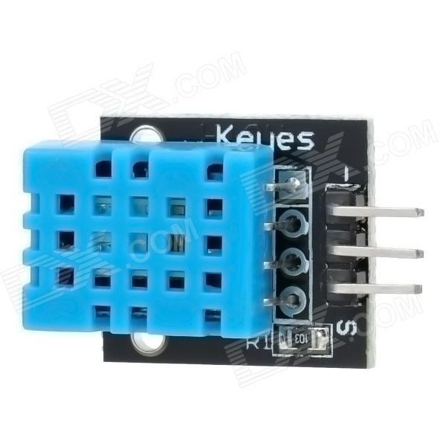

Pinout (Top to bottom): GND, VCC, Signal.

Connect Signal to any digital pin on the Arduino. VCC to +5v and GND to GND.

Please note, the DHT11 module can only return new values every roughly 2 seconds. Reading it too fast will result in invalid output being returned.

Ultrasonic sensor:

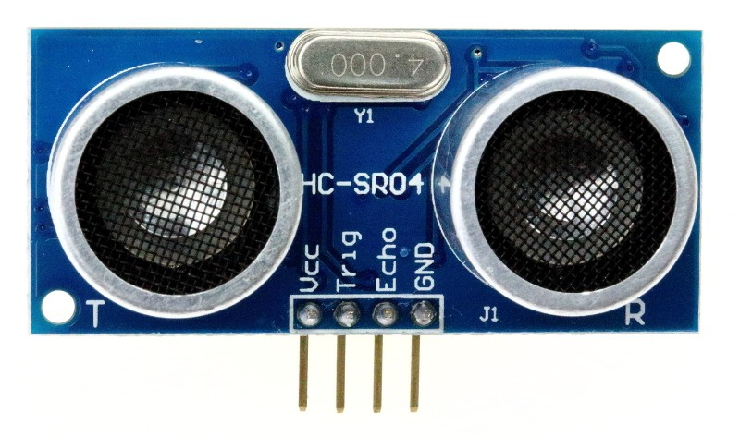

Pins on this sensor are labeled. Connect VCC to +5v, GND to GND. Short Trig and Echo and connect them to any digital pin on the Arduino. Divide returned value by 58 to get distance in Centimeters.

LCD Module:

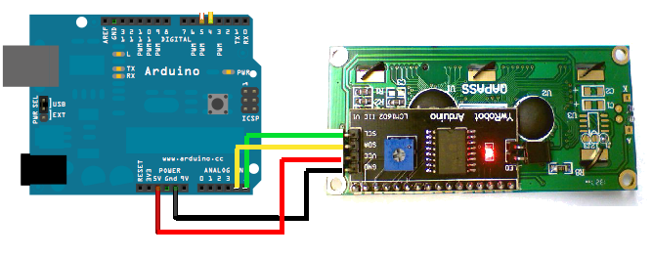

(NOTE: Module shown is not exactly the same, but the connections are the same. LCD has been hard coded for a 16 characters, 2 columns module).

If you do not see anything on the display after printing from Snap, try tweaking the contrast by turning the potentiometer on the back with a screwdriver.

Connect VCC to +5v and GND to GND. SDA to Analog pin 4 and SCL to Analog pin 5.

Please note that you will not be able to use analog pins 4 or 5 while using an I2C LCD display.